Chapter 13 Homework Problems

Problem 13.1

An impact-testing device consists of 20 kg box supported by two 5 kg slender rods. The two rods are set up in parallel so that the box remains level as it swings. If the whole system is released in the upright position shown below, what is the velocity of the box after traveling 90o?

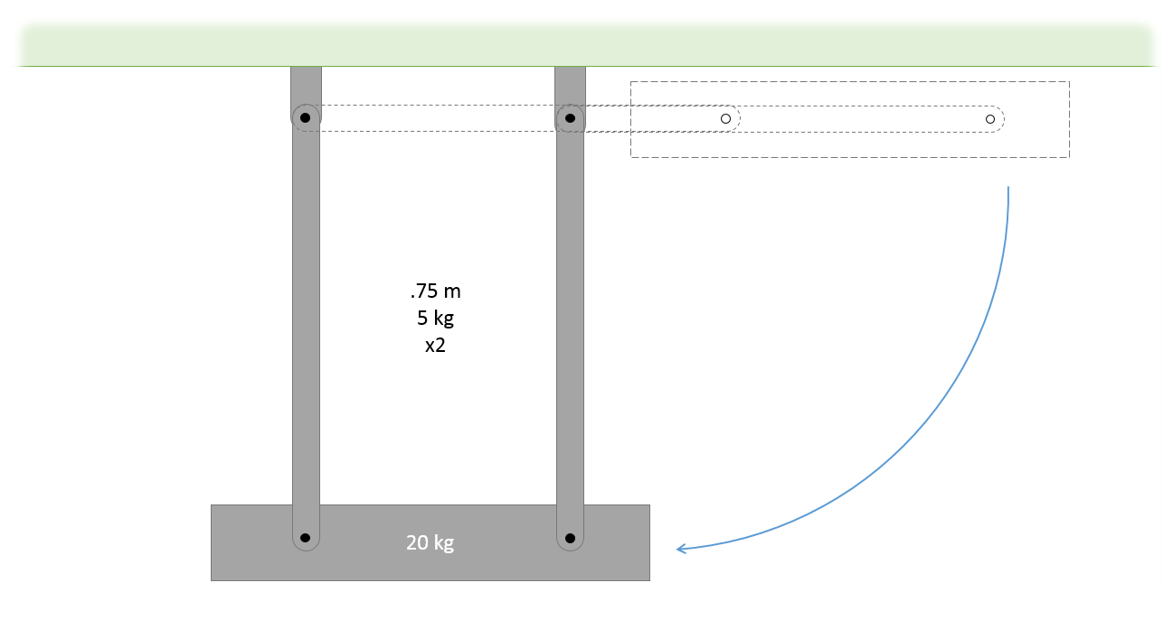

(Solution: v = 3.97 m/s)

Problem 13.2

A 40 lb door with a width of 36 inches has a spring with an unstretched length of 4 in designed to close the door when left open. The spring is anchored as shown below when closed (solid outline is closed, dotted outline is open 90o). If we want the door to have an angular velocity of .2 rad/s upon closing when released from rest at 90o, what should the spring constant of the spring be? (This is the top view of the door below)

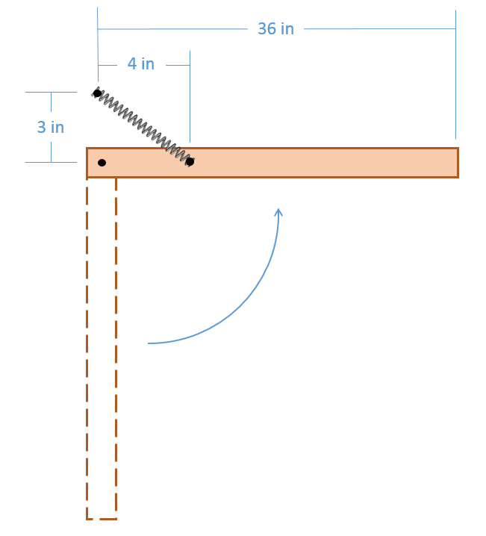

(Solution: k = 2.68 lbs/ft =.224 lbs/in)